| FAST National University |
| --- |
| **Introduction to DOSBox**  **Lab 1** |
|  |

**Computer Organization and Assembly Language**

| **Student Name** | Syed Baqir Abbas |
| --- | --- |
| **Registration #** |  |
| **Instructor** | Hazoor Ahmad |
| **Class** | CS3 |
| **Section** | A1, A2, D1, D2 |
| **Semester** | Fall 2022 |

Fast School of Computing

FAST-NU, Lahore, Pakistan

# Activity 1

## **Assembly Language Code**

[org 0x0100]

mov ax, 0x1254

mov bx, 0x0FFF

add ax, 0xEDAB

add ax, bx

add bx, 0xF001

mov ax,0x4c00

int 0x21

## **Debugging Screenshots**

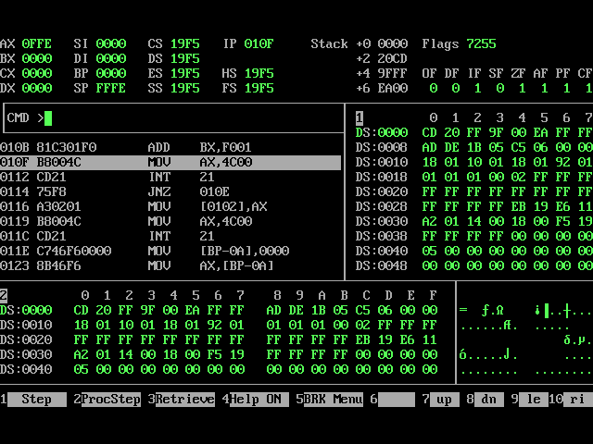

**Activity 2**

## **Assembly Language Code**

[org 0x0100]

*;; find square of val*

val : dw 5

result : dw 0

mov ax,0

mov bx,[val]

mov cx,5

start:add ax,bx

sub cx,1

jnz start

mov [result],ax

mov ax,0x4c00

int 0x21

## **Debugging Screenshots**

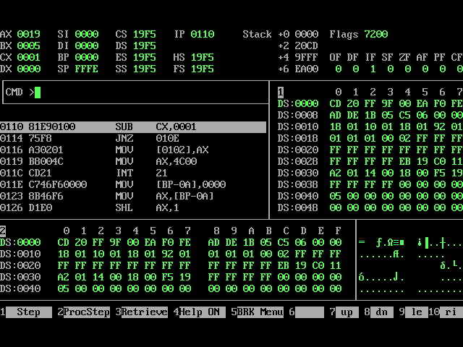

# Activity 3

## **Assembly Language Code**

[org 0x0100]

start: mov ax,[val]

mov bx,0

mov dx,0

comp: cmp [array+bx],ax

je next

add bx,2

cmp bx,44

je end

jne comp

next: add bx,2

add dx,1

jmp comp

end: mov ax, 0x4c00 *;terminate the program*

int 0x21

val: dw 9

array: dw 1,9,9,9,8,8,8,8,8,8,1,1,9,9,8,8,8,8,1,9,8,8

## **Debugging Screenshots**

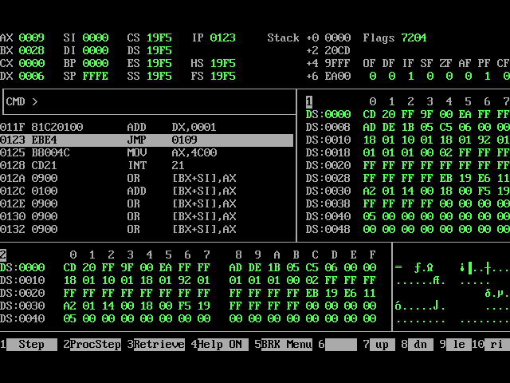

# Activity 4

## **Assembly Language Code**

[org 0x0100]

mov ax,3

mov bx,ax

l2:mov cx,bx

l1:add [factorial],bx

sub cx,1

cmp cx,0

jne l1

sub bx,1

cmp bx,1

jne l2

mov ax, 0x4c00 *;*

int 0x21

factorial : dw 0

## **Debugging Screenshots**

